Testing & Results
Using mentioned methods, the nationwide demand was analysed to give a better understanding of daily use, this data was then inserted into a database, the smart plug was connected to the gateway, and control over OH2 was established.

Peak Detection
The CSV data was read into the script via the Pandas library where it was unpacked and analysed to determine at what times during the day’s national demand peaks. The collected data was inserted into InfluxDB where it is avaible by web services like Grafana.

Pandas
In some of the values there were unrecorded values, the read_csv function excludes all these values and returns a dictionary.
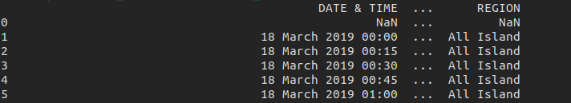
This was split into singular columns where the data type can be analysed uniformly. The demand was iterated through, the values were converted to integer values.
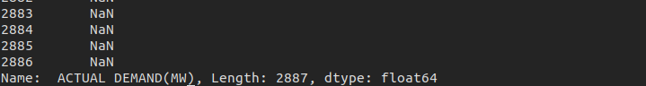
The indexes of the peaks were placed in list, these indexes were used to access the peaks in the demand dataframe.
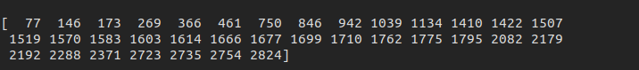
These peaks were then plotted over four days with Matplotlib in Figure isvdk. There are consistently four peaks a day with each peak number not being more than an hour from any other day.
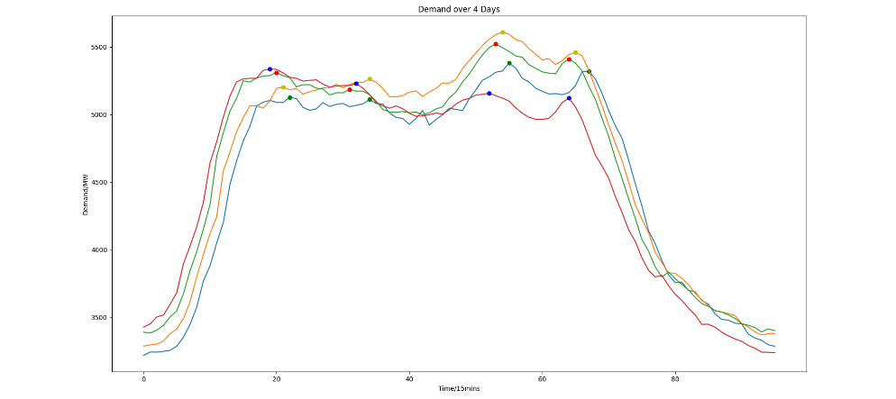

Plug Connection
Real-time monitoring is done with the plug sending data to the gateway where it can be used anywhere in the system. A domestic kettle was inserted into the smart plug and was monitored for several minutes, a 45 minute wash cycle was then tested.

Collection
Upon network activation the nodes can be accessed from the network instance, all information from this node is printed below, it shows the command class (METER), value (231.9) and the units (V), the below was only for one register.
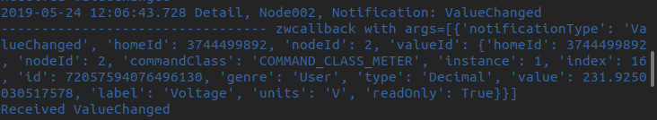
The get_sensors() returns all available sensors on the node, this can then be accessed by passing the register number to the get_sensor_value. For this testing only the current, voltage, and instantaneuous power was used but kWh is also available. The sensors are read every 23 seconds, the small sampling frequency is due to the need for a network restart on each loop.
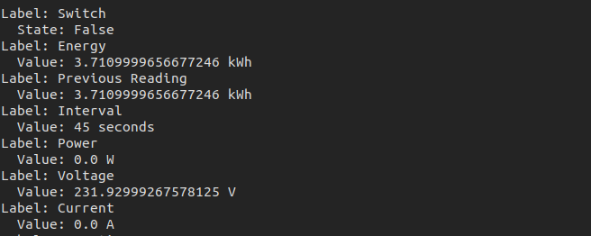

The historical data is retrieved with an Influx query which returns the past day of instantaneous demand values (Watts). The query retrieved was a dataframe nested in a JSON object, printed in Figure sabhasf.
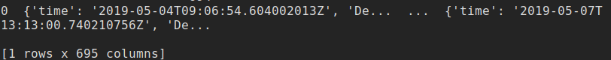
This is useless for analysis and must be converted to a dictionary first:

d_series = d_series.to_dict() # d_series is the raw query

Now in a dictionary format, where each key acts as an index for an entry, inside each enrtry, contains both timestamp and value:
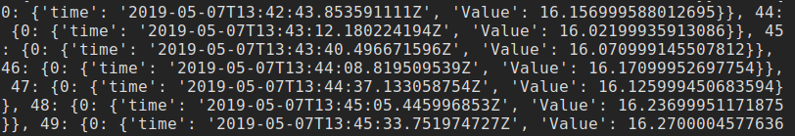
Still unusable, the dictionary was iterated over by using the .keys(), which accessed the key of the entry for each iteration, this was then appended to a list, specified first was the index, second 0, and third is the name, this case Value. The resulting terminal data structure is shown in Figure afbsfj. The ‘0’ was present in each entry and was added to access the data nested within it.

for val in d_series.keys(): # keys are the index in this case

val_list.append(d_series[val][0]['Value']) # makes list of values

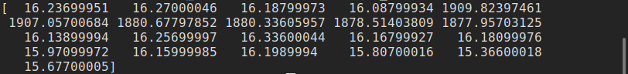
Last day of demand terminal
This is then compared to the current sensor value with the is_peak function which returns true in the event of a peak.

Visualisation
The recorderd values were stored in Influx where they can be accessed by the console but only in matrix-like format.
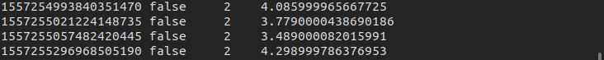
This was in nanoseconds since epoch which isn’t human readable so using the command below converts to Date Time Zone (DTZ) format.
precision rfc3339
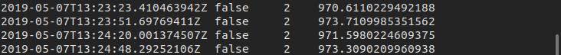
To use this data effectively, Grafana queried the database inside the online tool to plot all parameters needed. The kettle is recorded in the first demand group and the second group is the wash cycle:
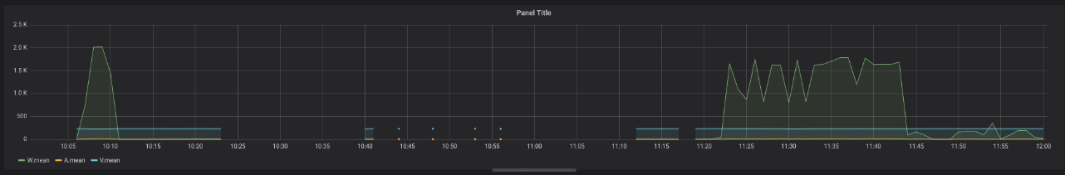
The time interval in the above was one minute, this offered a low degree of accuracy but showed a better overall view of the appliance’s use. The next diagram is recorded

OpenHAB Control
The controller was connected to the OH2 through the binding it offers, after adding to the dashboard, nodes can be added to the network. The plug is then added, the node was not automatically recognised and needed some time to communicate with the controller

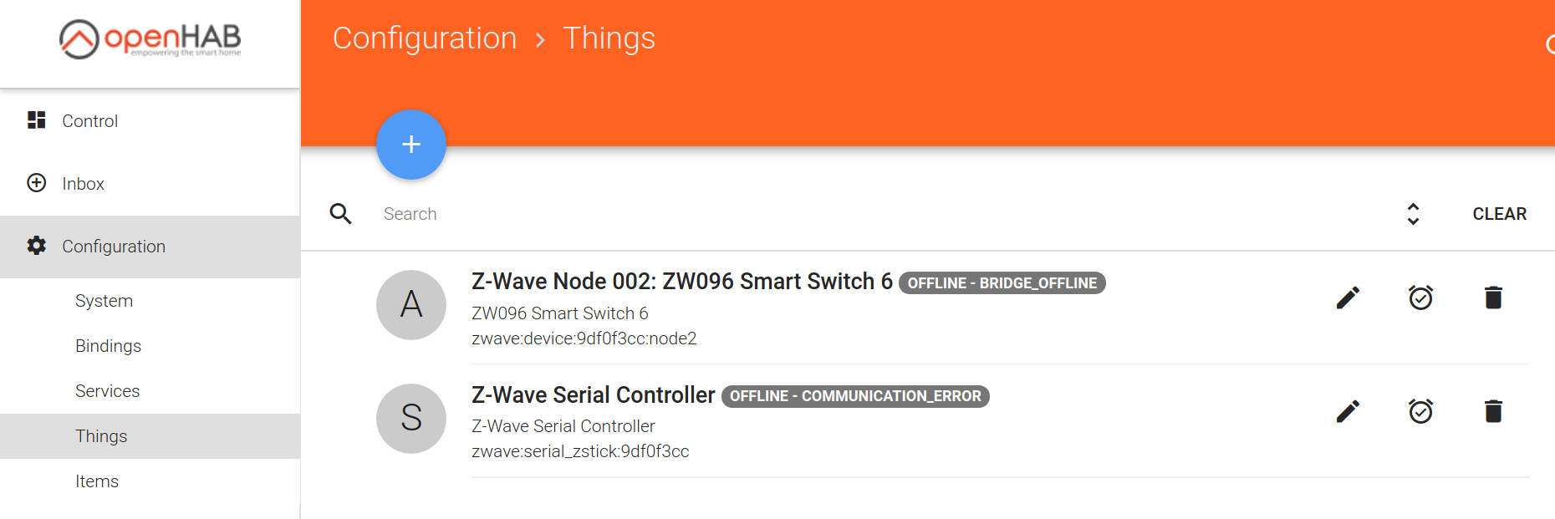
Channels were then added to the plug, all monitoring sensors except for the control of the switch. The switch can now be controlled via the GUI below.
